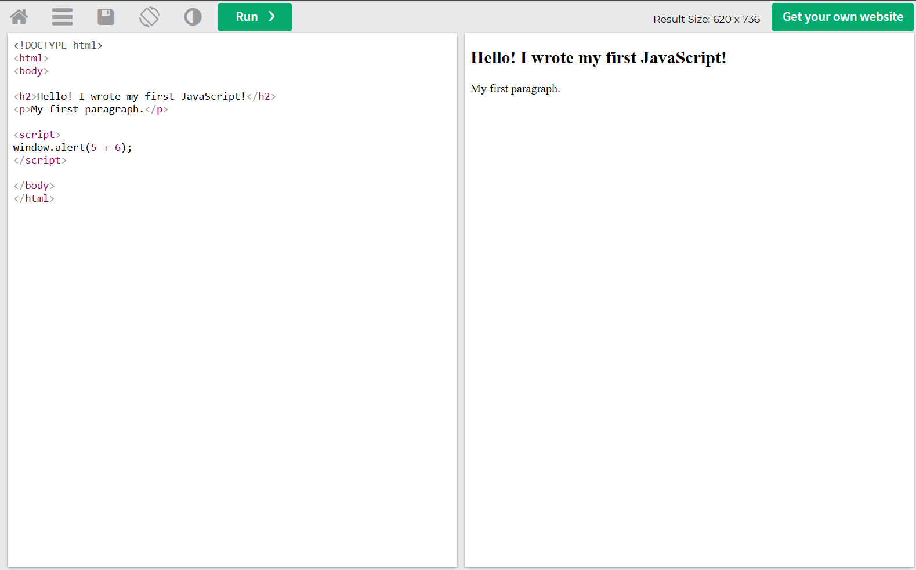
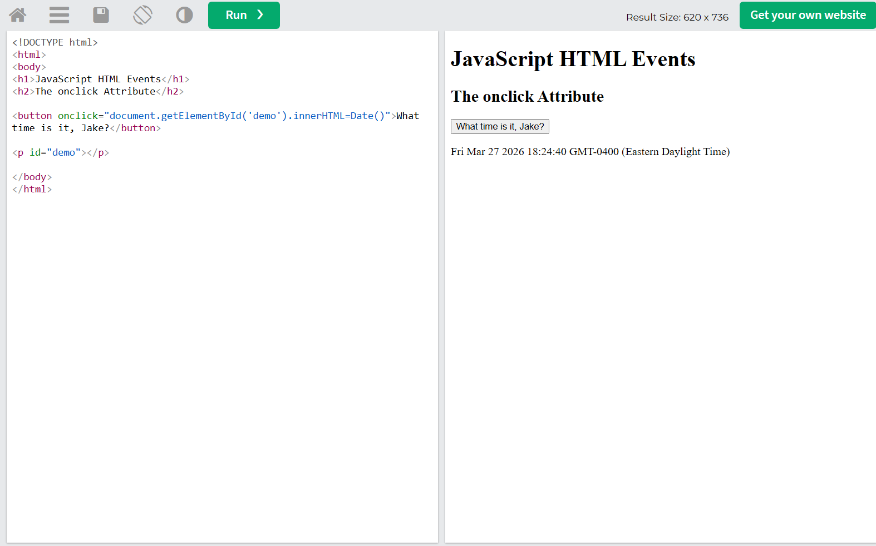

How are the two examples different and why does the JS Events example only activate when the button is clicked?
The two examples are different because the first uses “window.alert()” that will run as soon as the page loads. The second example, though, uses an attribute called “onclick” on a button that will only run the JS when the user clicks on it. In other words, the first one is activated automatically while the second one is activated manually by the user.
The JS is attached to an HTML event (the “onclick” specified above). This lets the browser know that it should wait and only execute the code when that exact event occurs. In this case, that means pushing the button attached to “onclick”. No button click means no event.
Which is the best control structure out of if, else, and else/if and why?
I believe the else/if statement is the most effective control structure because it allows you to handle more than one condition at a time and all in one block of code at that. The if and else alone don’t allow for much flexibility when it comes to larger scale projects or tasks.

